NVM: node version manager

Sometimes it is necessary to be able to quickly switch between versions of Node.js without having to uninstall and reinstall a new version.

* Perhaps one project is written for an older version of Node.js and works on that version, but you’d like to easily test it against a newer version of Node,
* Perhaps other projects you manage require a newer version of node and you need to be able to switch back and forth.

NVM (Node Version Manager) is a tool

* that allows to download and install multiple version of Node.js
* that enables the user to switch between different versions of Node.js

Installing NVM

Read the installation steps on <https://github.com/creationix/nvm>.

**Notes:**

nvm does not support Windows .Two alternatives exist, which are :

* nvm-windows : <https://github.com/coreybutler/nvm-windows>
* nodist : <https://github.com/marcelklehr/nodist>

Step 1: To download the nvm-windows: <https://github.com/coreybutler/nvm-windows/releases>

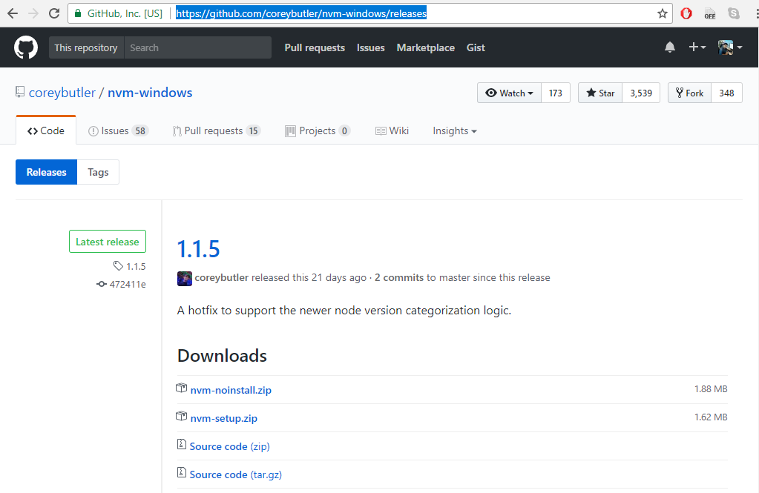

Step 2: install the downloaded nvm-windows installer

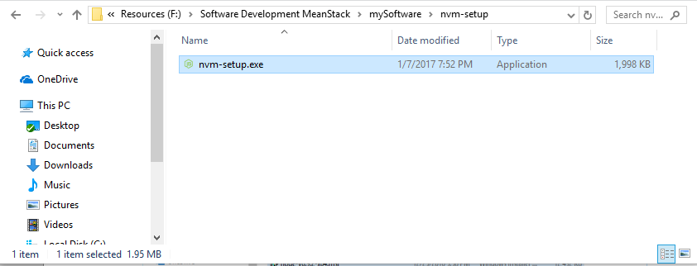

Step 3: after installation check that is it perfectly installed

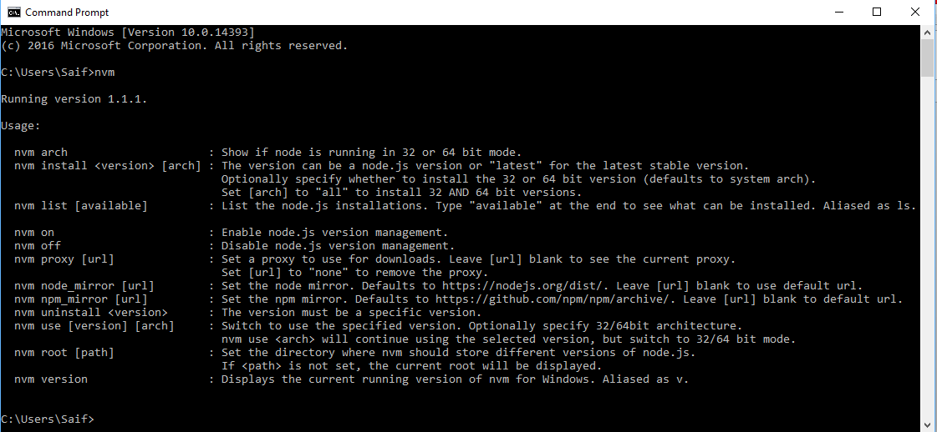

**Using nvm**

To download, compile, and install any version of node:

nvm install <version>

Check out what versions of Node.js are installed on your machine:

nvm ls

To use any installed version:

nvm use <version>

Check out what versions of Node.js is currently using on your machine:

node -v

To uninstall any version of node, do this:

nvm uninstall <version>

**Notes:**

Node version list: <https://nodejs.org/en/download/releases/>